How to Run the Project

1. Create a database in Mysql named glbitm
2. Create table in the dababase named employee and fill it with essential details

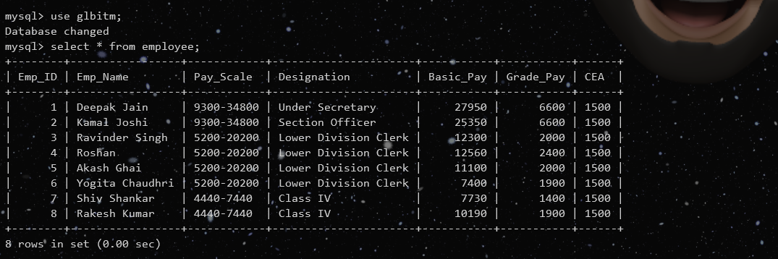

1. Run main.py
2. Modules Requires

* Tkinter
* Pillow
* OS
* Tempfile
* mysql.connector